AT24900 Design document
Lucero Durán Trinidad
April 30, 2018
School of aviation and transportation technology
Purdue Polytechnic Institute

Table of Contents

Abstract…………………………………………………………………………………………………………………………………………………..2
Application of Adult Education Principles……………………………………………………………………………………………..3-6
Summary of Course………………………………………………………………………………………………………………………………7-8
Context Analysis…………………………………………………………………………………………………………………………………8-14
Philosophies Considered in Development of Course…………………………………………………………………………14-16
Generation of Ideas………………………………………………………………………………………………………………………….16-17
Program Objectives……………………………………………………………………………………………………………………………….17
Course Setting………………………………………………………………………………………………………………………………….17-18
Course Approval……………………………………………………………………………………………………………………………….18-19
Obstacles………………………………………………………………………………………………………………………………………….19-20
Budget…………………………………………………………………………………………………………………………………………………..20
Transfer of Learning………………………………………………………………………………………………………………………….20-21
Evaluation Method…………………………………………………………………………………………………………………………..21-22
Report……………………………………………………………………………………………………………………………………………………22
AT24900 Mid-Course Evaluation………………………………………………………………………………………………………23-24
References…………………………………………………………………………………………………………………………………………….25
Addendum 1…………………………………………………………………………………………………………………………………….26-48
Addendum 2…………………………………………………………………………………………………………………………………….49-50

Abstract

AT24900 Instrument Lectures is a required course for students enrolled in the Professional Flight Program at the School of Aviation and Transportation Technology (SATT). The course consists of meeting twice a week for one hour and fifteen minutes and must meet the following requirements:

- Course content must meet the requirements set in Appendix C of Federal Aviation Regulation (FAR) Part 141, paragraph 3(a) and (b).
- Retain documentation and create course objectives in accordance with the Aviation Accreditation Board International (AABI) requirements.
- Comply with Purdue University rules and regulations.

This document will expand on these requirements to aid the instructor(s) in the creation
of the course materials. In addition, this document will also provide analyses for the students and context, including the organization and the wider environment, course objectives, information on the administration and process of approval for the course, including budgets, resources, barriers, and an evaluation tool. Furthermore, the document includes two addendums to give more information on AABI and a user guide to Blackboard Learn.

To accompany this document, a supplemental curriculum document will be created. The curriculum document will include the syllabus for the course, lesson plans for each session including the instructional materials for each session, and the required textbooks and/or material for the course. The curriculum will be created to give guidance on how to present the content of the course and to provide structure when changes are needed.

With these two documents in hand, it is hoped that an instructor will be more efficient at teaching the course and potentially using the structure of this course as a basis for other ground schools offered in the department. The learning theories and models used for this product may be useful as well in determining the success of the students and the course, as it would provide an “experimental” group that can be compared with the theories and philosophies used in other similar ground schools.

Application of Adult Education Principles
The course has been created using a behaviorist approach to adult learning. The behaviorist learning theory states that the training is instructor centered, defined by the course/learner objectives set, and deals with rewards and punishments (Merriam & Bierema, 2014). As the course has set content to be presented, per the FARs, and there is a time limit for the class, since exams and quiz time must be accounted for, there is very little room for extra content or missing class. Therefore, the course would have to be very structured to ensure all the requirements are met.

Additionally, specific course and learner objectives will be created to get a specific performance outcome. Especially since the FAA written examination has a specific 70% passing percentage. To ensure students get at least this percentage, an exam will be given to students with the learner objective being a 70% passing score. Once this is gained, the student would receive an endorsement from the instructor indicating they are ready to take the FAA written examination. All the material to be presented in class has textbooks and other reading material created by the FAA that includes specific answers to questions that could be asked in the written examination, therefore, presenting this information in the FAA’s format will help students practice seeing the information in that format.

To help students gain the most out of the behaviorist course, they will be encouraged to set goals. These goals will be encouraged to be mastery goals so that information can be stored in long-term memory and to give the students a little bit of freedom in the course. Using the TARGET acronym from the goal theory of motivation (Schunk, Meece, & Pintrich, 2014), the course will be able to have some goal orientations in the structure. Also, by setting a mastery goal, students’ motivations can change from just passing the class to comprehending the material to be used later in their flight courses. One example of how this theory and acronym will be used is by having students take time to find other students who want to study in groups. Then have them create a group goal, for example getting a score of 100% on the daily quiz.

In order to help students retain the material in long-term memory, three cognitive theories will be used in the creation of the instructional materials. The three theories are cognitive information processing, retrieval practice, and encoding specificity. The theories will be used as needed to match the material to be presented. The goal is to use these three as they will be able to account for differences in student learning styles and also provides various means to present information.

THEORY | DESPCPRITION | USEAGE IN PROJECT
Cognitive Information Processing (CIP)  References:  Driscoll (2014)  Duran Trinidad (2018) | Information is processed through 3 stages: sensory memory, working memory, and long-term memory.  There are processes used that allow the transfer of information through these stages, including:  - Attention  - Pattern recognition  - Chunking  - Rehearsal  - Encoding  The goal of an instructor is to use these processes to help learners store information in long-term memory. | This theory will be used in the creation of the instructional materials.  A comparable organizer created by Duran Trinidad (2018) and Table 3.3 from Driscoll (2014) give examples of how these processes can be applied by an instructor.
Retrieval Practice  References:  Roediger & Butler (2011)  Roediger & Karpicke (2006) | Using testing in an equal-interval schedule improves retention of information.  Merely studying material does not have much elaboration and gives the mind no practice at recall. | This principle is the basis for the creation of weekly quizzes. The quizzes will always be given on the second session of the week to ensure an equal-interval schedule.
Encoding Specificity  References:  Nairne (2015)  Driscoll (2014) | Retrieval will be greatly enhanced if the cues used during encoding are also the cues used in retrieval.  An abundance of cues will give learners a chance of having various associations created with information being retrieved. | This theory will be used in the creation of the instructional materials and ensuring there is a variety of ways the information is presented. This will account for differences in individuals, but also provide various cues that can be used for encoding and retrieval.  A comparable organizer created by Duran Trinidad (2018) and Table 3.3 from Driscoll (2014) give examples of how these processes can be applied by an instructor.
(Durán Trinidad, Project Proposal, 2018.)

In the creation of this course, the theories explained above were used in various places of the curriculum. The following paragraphs will talk about how each theory was applied and give some examples.
Behaviorist Approach
The behaviorist approach was used in various lesson plans in the curriculum. Since the class is set to be at least a minimum of 50 students, it was determined that PowerPoint presentations with lecture or discussion would be the best method of delivery. By having a presentation with the material to be covered in a session, the instructor has received complete control of how the session is to be run. By referencing the Curriculum Outline, it is evident that many lesson plans’ materials include PowerPoint presentations.
One such session that has the most behaviorist approach would be Sessions 9 & 10. In this session, the topic covered is Federal Aviation Regulations (or the “Rules of the Sky”). This topic is bland and full of legal jargon, that only an experienced pilot can interpret and have a better understanding. Since the course is composed of inexperienced pilots, it is up to the instructor (the experienced pilot) to present the regulations in “normal English” so that students can understand the concepts and ideas behind the creation of the regulations.
Another instance where behavioristic theory is extremely obvious in the curriculum is in Sessions 21 & 22. These sessions cover aviation weather theory that is critical in understanding potential hazards in flight. This session covers a multitude of material that can only be covered in the given period with the instructor if full control of the session. Although the students should know some of the information in these sessions, the instructor must continue along and not wait for answers from the class (if asked a question), or continue explaining a topic that a student is confused about, to ensure all the material is covered.
TARGET Acronym
The TARGET acronym from the goal theory of motivation was used in various places in the curriculum for this course. Once such instance can be found on the first session of the course (page 2 of Curriculum Outline). An activity was created where students get to write a goal they have for the class in an index card. Each student will be accountable to reach the goal they wrote in their index card, which may serve as motivation for the course. In addition, the acronym was also used to create relevance in the students’ pilot careers of the course. By spending fifteen minutes discussing with the class the importance of the information of the course and how it relates to them, will aid them in setting even more goals to be successful in the course.
Furthermore, in Session 13 the acronym is once again used. This session is on the topic of aeromedical factors, which is a topic the students are familiar with, as they have learned it when becoming private pilots. The session is set up to have the instructor ask questions to the class about the factors before presenting the information on the slide. This action forces the students to be engaged (as the instructor can select any student to answer question) and challenged as the students are forced to recall information that may not be so fresh in their minds.
Cognitive Information Processing (CIP)
Some of the concepts of CIP include chunking, attention, and rehearsal. These concepts were used throughout the curriculum, specifically in the creation of the PowerPoint presentations. One such example is in Sessions 11 & 12, where multiple topics where covered. These sessions had to cover three distinct topics that were somewhat related. In order to ensure flow between topics, the lesson plan was set to differentiate the topics. In other words, the topics were “chunked” into their own categories and different PowerPoint presentation made for each. In addition, under the topic of Airports, there were mini sub-groups of information presented. This information was once again “chunked” to their respective areas, i.e. airport markings, airport lights, and airport signs, to distinguish the material.
Attention was used in various lessons by having the instructor recall situations from their own flying experiences. In the session covering departure, en route, and arrival procedures, the instructor is prompted to provide real world examples of the material to the students. By telling these “stories” the students’ attention is gathered, as well as relevance and meaning, to at least continue to pay attention for a few more minutes. In the aerodynamics session, videos, instructor drawings, and diagrams are used to get the students attention and divert them from a potential monotone instructor.
Lastly, rehearsal, which can be paired with retrieval practice, was used in the course by the use of quizzes and discussion questions given by the instructor. The quizzes aim to review information that may have been taught in a lesson or read from the reading assignments, and recalled (rehearsed) by the students at various times during the semester.
Retrieval Practice
Retrieval practice is the principle of practicing recalling information form short or long-term memory. Quizzes, discussions with questions, and exams, were used to accomplish the integration of this theory. In the lesson plans found in the Curriculum Outline, there are a few sessions covering topics already known by the students. In these sessions, the instructor was prompted to have a discussion with the class, rather than lecture, so that he/she can ask questions to the students and have them recall information. One example of this is the session covering holding patterns. In the second day of this topic, the instructor is prompted to select individual students to come to the front of the class to interpret a clearance and determine an entry to the holding procedure. This simple act of recalling information can help encode the information and make the student understand it better.
Encoding Specificity
Encoding Specificity is the use of various cues to help an individual store and recall information in long-term memory. This concept can be found in various lesson plans. One example can be found in Sessions 9 & 10 and Sessions 19 & 20. These sessions covered two different topics, but there is one similarity between the two, minimum IFR cruising altitudes. In the first sessions presented the altitudes from a regulation stand point, where as in the last two sessions they were a symbol and a mandatory altitude in charts. Although the information was the same, the fact that they were presented in two distinct “environments” allowed the students to create different cues that may later help in recall. Another example of the use of this theory can be found in the session covering holds. In this session, a video, outside of only instructor lecture, was used to help students understand the concept of holding.
Summary of the Course

For a student to progress in the Professional Flight Program in SATT, he/she must take AT24900 Instrument Lectures. The course serves as ground course in the program that meets two course objectives:

- The course is a preparation for the Federal Aviation Administration’s (FAA) Instrument Rating written examination.
- The course is intended to present the aeronautical knowledge needed to operate an airplane safely and efficiently as an instrument rated pilot in instrument meteorological conditions.
(AT24900 Instrument Flight Lectures Syllabus, 2018)

The FAA’s Instrument Rating written examination is a requisite that must be accomplished by any pilot wanting to get an instrument rating added to a pilot certificate. Per the FAA, a passing grade on the written examination is a seventy percent or higher. Therefore, the course will have to ensure that each student will be able to at least achieve this minimum. Once the written examination is complete the pilot would be able to take the practical exam, which includes the oral and flight examinations. Essentially, without the written examination complete, a student in the Professional Flight Program would not complete the AT25302 flight course (this course is the flight training) since the “final exam” is the practical exam for the instrument rating. Although the Professional Flight Program includes a course to provide the flight training required for the instrument rating, there is ground knowledge that must be given to the students to be successful in that course. This is the main reason for the second course objective. As a pilot learns to fly an aircraft he/she must also learn the knowledge necessary to make decision and have a safe flight and not just the motor skills.

As it stands, the Professional Flight Program is recognized by the FAA as a Part 141 flight training provider. To maintain this status, the school must continuously meet the requirements set in FAR Part 141 and be able to prove it during regular audits. In FAR Part 141, Appendix C spells out the requirements the school must meet to have an instrument rating course. In this appendix, paragraph 3(a) and (b) are the requirements for the ground course, i.e. AT24900. The requirements are as follows:

3. Aeronautical knowledge training. (a) Each approved course must include at least the following ground training…..listed in paragraph (b) of this section appropriate to the instrument rating for which the course applies:
(1) 30 hours of training if the course is for an initial instrument rating;…….
(b) Ground training must include the following aeronautical knowledge areas:
(1) Applicable Federal Aviation Regulations for IFR flight operations;
(2) Appropriate information in the “Aeronautical Information Manual”;
(3) Air traffic control system and procedures for instrument flight operations;
(4) IFR navigation and approaches by use of navigation systems;
(5) Use of IFR en route and instrument approach procedure charts;
(6) Procurement and use of aviation weather report and forecasts, and the elements of forecasting weather trends on the basis of that information and personal observation of weather conditions;
(7) Safe and efficient operation of aircraft under instrument flight rules and conditions;
(8) Recognition of critical weather situations and windshear avoidance;
(9) Aeronautical decision making and judgment; and
(10) Crew resource management, to include crew communication and coordination.
(FAA, 2018)

Since this FAR states the content for this course, this is what will be included in the syllabus. To present the content without the legal wording and in a manner that makes sense, the following is the order this content will be presented in the course.

- Flight Instruments
- Attitude Instrument Flying
- Navigation Systems
- Federal Aviation Regulations
- Airport Lighting and Markings and ATC
- Aeromedical Factors
- Holding Pattern Procedures
- Instrument Approach Procedures
- Instrument Departure, Enroute, Arrival
- Instrument (IFR) Charts
- Aviation Weather and Weather Services
- IFR Flight Planning
(AT24900 Instrument Flight Lectures Syllabus, 2018)

Context Analysis

Human Element

Before creating any instructional materials, a designer must have information on the human elements that affect the program. This section includes a learner analysis and the individuals who may have input or guidance for the course.

Learner Analysis

Who | Young adults enrolled in the Professional Flight Program. The class may include students in other majors who are taking the course as an elective.
The class size is topped at 50 students. The class size may be increased if a student(s) must re-take the class or aren’t able to take it in a future semester.
The class is taken either on the second semester of freshman year or the first semester of sophomore year.
Majority of students in the program are male and Caucasian, thus a small amount of females and minorities are expected in the course.
Motivations | This course a core requirement for the Professional Flight Program. This course must be taken prior to enrolling in AT25302 as it meets the prerequisites for the instrument rating.
- A passing grade must be attained in order to continue in the program. As such, a student will try to not re-take the class as that may put them a semester behind.
- Students outside the program (taking the course for an elective) are motivated by interest in the material. They are just aiming for a passing grade to not affect their GPA.
- The material provided is such that will need to be retained in the long-term as pilots will use it for the rest of their career. Therefore, students will try to comprehend the material to ensure material stores in long-term memory.
Constraints | Age:  - Most will be college students, therefore learning rate will be similar.  - Sometimes have older individuals whose learning rate is different than college students. Also, these individuals may have been separated from academia for a time that learning and studying techniques may have to be retaught.  Time:  - Students are enrolled in a flight course, which requires a high time commitment; thus, students may not have much time left for studying or homework.  - Students could be enrolled in ROTC, which can have high time commitments as well.  - Other classes or extra-curricular activities (clubs, sports, etc) may limit the time outside of class for studying and homework.  - Some students may have family or work responsibilities (mostly older individuals) that can affect time availability.  Technology:  - Depending on backgrounds, students may have a strong or weak knowledge of technology use.  - Students may not have technological devices with them, or may have limited access. Devices can include, laptop, iPad, tablet, smart phone, etc.  - Students may use technological devices in class (to take notes or follow along on powerpoints) that may distract from the class.  Class Size:  - The class is a large lecture (up to 50 students) therefore many may not feel comfortable speaking out with questions.  - Students will not be able to have one-on-one interaction with the instructor(s) unless are able to attend office hours.  - Since time for the course is limited, class activities or group work may not be possible with such a large class size; therefore, students who benefit from these activities won’t have the opportunity.  Transportation:  - Bus: the bus runs every 20 minutes to the airport. Therefore, they either have to take a super early bus to be on time or take a bus that will either make then 5 minutes or 15 minutes late.  - Car: must have a parking permit that costs money. Additionally, parking space is limited and may not find a spot.  - Weather: if the weather is not permitting, students would not be able to walk or ride their bike. Making them drive or take the bus.  Distance:  - The course is taught at the Purdue University Airport. It is located on the southwest corner of campus. It is at least a 10 minute drive, a 45 minute walk, or a 15-20 minute bike ride from main campus.
Prior Knowledge/Skills | Depending on the background of student, he/she may some instrument flying knowledge obtained from the military or home (if have a relative or friend who is instrument rated).  Otherwise, each student in the course must meet the prerequisite of the course:  - Have a private pilot certificate or pass AT14400.  Therefore, each student will have ground knowledge on aviation material. Since some of the content has been taught for the private pilot certificate or in AT14400, those sections will serve as a review.

The following chart includes the various individuals who may be involved in the creation or evaluation of the course, with their titles and short description of their involvement.

Lucero Duran Trinidad*  Michael Gref* | Instructors of the Course | They present the material to the students and interact with them. Can make changes to curriculum as needed based on student performance, feedback, or course objectives.
Manoj S. Patankar | Department Head of SATT | As department head he ensures that all instructors are meeting requirements set by Purdue, the department, and AABI. He may provide funding for materials, guest speakers, fieldtrips, etc. if necessary.
Thomas Carney | Professor of SATT | Dr. Carney is the subject matter expert on AABI. He can answer questions on AABI requirements, keeping of records, and insights on how he meets the requirements for his classes.
Flight Instructors | Purdue Flight Instructors | Provides insights on student(s) and their learning styles as they would have more one-on-one time with them. May aid with studying and/or teaching of material.
Previous Students | Graduates of Program | Provide feedback on the set-up of the course as well as any changes they would like to see based on their experiences.
Ronda Cassens | Chief Flight Instructor Purdue University | Conducts stage checks for students who are close to getting instrument rating. May provide feedback on weak areas to ensure those are improved for next class.  As an instructor with extensive flying experience, may provide insight into IFR flying and answer questions instructors of course may not. May also provide feedback on how to present certain material.
Brian Dillman | FAA DPE  Associate Professor of SATT | Does practical exams with each student and provides feedback on weak areas (of previous students) to ensure those areas are improved for the next class.  As professor of other ground courses, he can provide insight on how to structure course to meet objectives and dealing with large class sizes.
Larry Gross | FAA DPE  Associate Professor of SATT | Previous instructor of this course. Will be able to provide feedback on how to teach material and maintaining records.  Does practical exams with each student and provides feedback on weak areas (of previous students) to ensure those areas are improved for the next class.
Steve Stombaugh | FAA appointed Inspector for Purdue University’s Flight Program | Is available to answer any questions regarding FARs, inquiries about IFR flight concerns, and adherence to the requirements in FAR Part 141.
ATC Manager and Controllers | Lafayette Tower (ATC) | Encourages open communication between program and ATC to ensure safety and proper adherence to FARs. Can provide insight into ATC procedures related to IFR flight.
*Instructors of the course may change. For Spring and Fall 2018 these are the instructors scheduled to teach the course.

Organizational Element

The course is part of the Professional Flight Program’s curriculum. This program is one of seven majors offered by the School of Aviation and Transportation Technology (SATT) at Purdue University. The program is based on the Purdue University airport, with its lecture halls, labs, and hangars located there. Being part of the Purdue Polytechnic, SATT must maintain not only their specific goals, but also the Polytechnic’s and the University’s. Therefore, SATT’s mission statement is as follows:

“The mission of the School of Aviation and Transportation Technology is to support the missions of the Purdue Polytechnic Institute and Purdue University in serving the citizens of the State of Indiana, the nation, and the world, through learning, scholarship (discovery), and engagement activities that extend aviation technology education, aviation technology discovery efforts and technology transfer, and implementation (application) of emerging technology for the global aviation industry. Student learning is advanced by discovery and engagement activities that enhance economic and social development.”
(Aviation and Transportation Technology, 2016).

To achieve this mission statement, SATT has created curriculums that encourage participation of the aviation industry, as can be seen on their website with the number of industry connections. Also, its curriculums strive to have a high quality of graduate by ensuring the school is AABI and Accreditation Board for Engineering and Technology (ABET), for the engineering technology majors, accredited. In fact, it has to maintain its quality of instruction to stay in the top ten best aviation schools, ranked as third on Paramount Business Jets in 2015 and first by The Best College and Air Charter Service in 2018.

Power Structure

The current hierarchy structure within the SATT department is as follows:

Instructors of the course Chief Flight Instructor Department Head

At the current moment, two flight instructors in the Professional Flight Program are the instructors for the course. As their main job is flight instructing, their immediate supervisor is the program’s chief flight instructor. As can be seen, the chief’s supervisor is the department head. Although the chief flight instructor may not have much say on what is being taught in the lecture, he/she will be able to send any concerns further up the chain of command.

From the diagram above, the instructors of the course can go directly to the department head. At SATT, the department head has an “open door” policy that allows anyone who wants to talk to him come in, assuming he is free. Therefore, even if the instructors of this course are flight instructors, they should feel comfortable skipping their immediate supervisor. If the instructors of the course eventually become faculty members (professors), then the power structure changes to having the department head as their immediate supervisor.

As we mentioned earlier, there are many individuals who can provide feedback and support for the course. For this reason, these individuals become resources and support for the instructors in case any concerns were to come up.

Environmental Element

The main building for SATT is the Niswonger Aviation Technology
Building which includes lecture halls, computer labs, hangars space, and administrative offices. One of the lecture halls in this building will be used to teach the AT24900 course. As the airport and buildings are owned by Purdue University, the instructors of this course and students must follow university rules and regulations concerning rules of conduct, illegal substances and alcohol, academic policies, emergency plans, and any other policies required by the university. Some of these rules and regulations will be included in the syllabus, but the rest can be found on the Purdue University website.

To ensure that the setting for this course is appropriate the following chart explains availability of resources and technology.

Financial Resources | The course being part of the Professional Flight major, students have paid tuition fees to cover expenses by the department to teach this course.  Any additional expenses, would have to be approved by the department head as funding would have to be budgeted into the department’s budget.
Teaching Environment | The ground course will take place at the airport in the Niswonger building.  - The course will be in a lecture hall that can fit at least 70 people and has adjustable chairs.  - The use of a computer lab may be required, which can be found in the same building or in main campus.  - The lecture hall is accessible to students in the program as it is in the main floor of building and at the airport.  - The lecture hall is reserved ahead of time by the department.
Materials | Textbooks, sectional charts, videos, assignments, advisory circulars, PTS, and any other materials will be provided to the students by the instructor (through Blackboard or in paper) or through the FAA website assuming they are free and public records.
Instructor | For the ground course there will be one or two main instructors to teach the material. As the instructors are also flight instructors and employee of Purdue, which includes other responsibilities, the availability outside of class will be limited.  If the instructor is taught by a professor, he/she may have other responsibilities as well that may limit time outside of class.

Technology

The available technology that is accessible for the course includes technology found in the lecture hall to be used. It includes a projector that can receive input from the classroom computer, laptop, or Doc Cam. A chalkboard and audio system are also available in the lecture hall. The main platform to provide materials to the students will be Blackboard Learn, with email being the second platform. Lastly, as material will be presented in electronic format, if the students don’t have access to a personal technology tool, there are various computers labs at the Niswonger building and around campus for them to access and print materials (if needed).

Wider Environment

Purdue Aviation, the Fixed-Based Operator (FBO) on the field, provides materials required by the students in the flight program as well as a location to take the FAA’s written examination. Considering the hours of operation will be crucial when students are ready to take the FAA written examination. As the only FBO in the area, it serves any pilot in the community who wants to schedule a time to take any type of written exam, not just Purdue flight students. Therefore, ensuring the FBO will be open and available during time(s)/day(s) needed by students to take their written exam is important. This information will have to be presented to students early in the course so that they may be able to plan accordingly and schedule their written examination before the FBO gets full.
Since the course must follow the FARs, as any of these are changed by the FAA, applicable changes may have to be applied to the course. In addition, since the course is under the Part 141 certification granted to the flight program, it is subject to audits by the FAA Flight Standards District Office (FSDO) in Indianapolis, IN. Furthermore, as the syllabus is part of the documentation that must be audited, any changes the instructors want to make to it will have to be approved by the FSDO before they can be applied and enforced in the course. As audits and approvals take time, it is advised that any changes to the syllabus be made in accordance with the scheduled changes the flight program wants to make to their documents.

Philosophies Considered in Development of Course

The course will be created using a behaviorist approach to adult learning. The behaviorist learning theory states that the training is instructor centered, defined by the course/learner objectives set, and deals with rewards and punishments (Merriam & Bierema, 2014). As the course has set content to be presented, per the FARs, and there is a time limit for the class, since exams and quiz time must be accounted for, there is very little room for extra content or missing class. Therefore, the course would have to be very structured to ensure all the requirements are met.

Additionally, specific course and learner objectives will be created to get a specific performance outcome. Especially since the FAA written examination has a specific 70% passing percentage. To ensure students get at least this percentage, an exam will be given to students with the learner objective being a 70% passing score. Once this is gained, the student would receive an endorsement from the instructor indicating they are ready to take the FAA written examination. All the material to be presented in class has textbooks and other reading material created by the FAA that includes specific answers to questions that could be asked in the written examination, therefore, presenting this information in the FAA’s format will help students practice seeing the information in that format.

To help students gain the most out of the behaviorist course, they will be encouraged to set goals. These goals will be encouraged to be mastery goals so that information can be stored in long-term memory and to give the students a little bit of freedom in the course. Using the TARGET acronym from the goal theory of motivation (Schunk, Meece, & Pintrich, 2014), the course will be able to have some goal orientations in the structure. Also, by setting a mastery goal, students’ motivations can change from just passing the class to comprehending the material to be used later in their flight courses. One example of how this theory and acronym will be used is by having students take time to find other students who want to study in groups. Then have them create a group goal, for example getting a score of 100% on the daily quiz.

In order to help students retain the material in long-term memory, three cognitive theories will be used in the creation of the instructional materials. The three theories are cognitive information processing, retrieval practice, and encoding specificity. The theories will be used as needed to match the material to be presented. The goal is to use these three as they will be able to account for differences in student learning styles and also provides various means to present information. The supplemental curriculum document will have specified which theories were used in the instructional materials to aid the evaluator of the course see how they were used. The following table gives a brief description of these theories and references for them.

THEORY | DESPCPRITION | USEAGE IN PROJECT
Cognitive Information Processing (CIP)  References:  Driscoll (2014)  Duran Trinidad (2018) | Information is processed through 3 stages: sensory memory, working memory, and long-term memory.  There are processes used that allow the transfer of information through these stages, including:  - Attention  - Pattern recognition  - Chunking  - Rehearsal  - Encoding  The goal of an instructor is to use these processes to help learners store information in long-term memory. | This theory will be used in the creation of the instructional materials.  A comparable organizer created by Duran Trinidad (2018) and Table 3.3 from Driscoll (2014) give examples of how these processes can be applied by an instructor.
Retrieval Practice  References:  Roediger & Butler (2011)  Roediger & Karpicke (2006) | Using testing in an equal-interval schedule improves retention of information.  Merely studying material does not have much elaboration and gives the mind no practice at recall. | This principle is the basis for the creation of weekly quizzes. The quizzes will always be given on the second session of the week to ensure an equal-interval schedule.
Encoding Specificity  References:  Nairne (2015)  Driscoll (2014) | Retrieval will be greatly enhanced if the cues used during encoding are also the cues used in retrieval.  An abundance of cues will give learners a chance of having various associations created with information being retrieved. | This theory will be used in the creation of the instructional materials and ensuring there is a variety of ways the information is presented. This will account for differences in individuals, but also provide various cues that can be used for encoding and retrieval.  A comparable organizer created by Duran Trinidad (2018) and Table 3.3 from Driscoll (2014) give examples of how these processes can be applied by an instructor.
(Durán Trinidad, Project Proposal, 2018.)

Lastly, the course will use some aspects of the experiential learning theory. This theory states that experiences are a resource to learners and that will affect learning and motivations. Any new learning that takes place will be able to be tied to past experiences, which should help with transfer of learning, and will produce future outcomes (Merriam & Bierema, 2014). As students in this course are private pilots, they have experience flying a plane. They may also have some experience in instrument flying, if they’ve had the opportunity through a family member or friend. Therefore, the course material is an addition to the aviation knowledge they already have. Also, since some of the material may be hard to comprehend on a ground setting, it will have to be presented in a way that is tied to a previously learned flight maneuver. For example, when teaching about flying a VOR approach (a type of instrument maneuver), the instructor can help them visualize the procedure as it is very similar to flying a VOR radial to the station (a maneuver they are familiar with).

Generation of Ideas

To determine the content for this course, the following was used:

TECHNIQUE | DESCRIPTION
Observations | Observations were made of class being taught in previous semesters.  From taking the course, my own observations of what was taught in the course.
Interviews | In Fall 2017: Interviewed previous professor of course on the content that was taught in the course. We were able to get his notes, exams, and other documents he used.
Documents and Artifacts | The following documents were reviewed:  - Notes from previous professor  - FAR/AIM book  - GLEIM Instrument Rating preparation book  - PowerPoint presentations from instrument course taught in another collegiate program.
Informal Interactions | Conversations with other instructor of course were conducted to determine what content he taught in his collegiate program.  Flight instructors were talked to about weak areas noticed on stage checks (flight exams) to determine if could strengthen those weaknesses in course.  Designated Pilot Examiners (DPE) talked about weak areas in the oral part of the exams to determine what content should be taught.

To sort and prioritize the content that was obtained through the techniques explained above, the two major documents that were consulted were the GLEIM Instrument Rating preparation book and the FAR/AIM book. The GLEIM preparation book includes the question bank the FAA uses to create their written examinations, therefore, this book includes the content a pilot would need to learn to pass the exam. Also, as mentioned in the “Summary of Course” section of this document, the FARs state the minimum content that must be taught in the course (the regulation can be found in the FAR/AIM book or online at faa.gov).
Furthermore, looking at the number of weeks the course was to be, 16 weeks per the Purdue University calendar, and the amount of times the course would meet a week, it was determined that only the minimum content found in the FARs would be able to be covered. This would allow one content area to be taught for week, giving time for more in-depth description of the content and allow students time to finish reading assignments and understand content.
For these reasons, the following is the content that will be taught in the course:
- Flight Instruments
- Attitude Instrument Flying
- Navigation Systems
- Federal Aviation Regulations
- Airport Lighting and Markings and ATC
- Aeromedical Factors
- Holding Pattern Procedures
- Instrument Approach Procedures
- Instrument Departure, Enroute, Arrival
- Instrument (IFR) Charts
- Aviation Weather and Weather Services
- IFR Flight Planning

Program Objectives
As it stands, there is only once course objective for the AT24900 course, which can be found in the current version of the course syllabus. To make the objective more measurable the objective will be revised. Additionally, a second course objective will be created to meet the main goal of this course. It is important to understand that the course objectives below will not be applied to the course immediately. The syllabus for the course is submitted as a part of the Training Curriculum Outline (TCO) for the Flight Program at Purdue that is sent to the FAA’s FSDO in Indianapolis, IN. The TCO would have to be approved by the FSDO before any changes can be made to the course. As the flight program submitted a new revision of the TCO to the FSDO in January, the changes of these course objectives would be applied whenever the flight program send another revision to the FSDO.
The following are what the course objectives would eventually be:
- At the end of the course, the students will know the material necessary to pass the FAA Instrument Rating written examination with a score of 70% or higher.

- The course will present the aeronautical knowledge needed to operate an airplane safely and efficiently as an instrument rated pilot in instrument meteorological conditions.

- The course will integrate various adult learning theories and models that can reframe how aviation ground schools are taught, by acting as a model.
Course Setting
The course setting is the following:

ASPECT | DESCRIPTION/RATIONALE
Location: Lecture hall in Niswonger Building  The Niswonger building is the main building for the SATT. It is located on the Purdue University airport and includes various lecture halls, computer labs, office spaces, labs, and hangar space. | Due to its central location at the airport, students will have easy access to the building. Additionally, there is a campus loop that stops at the front door and enough parking at the airport for those students that drive. Furthermore, the airport includes safe walking and bike areas for those students that walk or ride the bike.  The lecture hall has been picked for the setting as it includes:  - Sitting for at least 70 people and has adjustable chairs.  - A projector that can receive input from the classroom computer, laptop, or Doc Cam.  - A chalkboard and audio system
Date: Tuesdays and Thursdays | To ensure that enough time was used to meet the course credits and to cover the content, the course was selected to meet twice a week. Meeting twice a week also allows students with time to do homework assignments and find time to fly or for other classes.
Time: 1:30 PM – 2:45 PM | AT24900 being a required course for students in the flight program, it had to ensure it wouldn’t interfere with a student’s flight schedule. Therefore, the class was assigned to start at 1:30pm as that is also the start time of a “flight slot” and would end at 2:45pm (before the next “flight slot” began). In this scenario, students would only lose two “flight slots” a week (a week has a total of 42 possible flight slots).

Course Approval
As mentioned before, AT24900 Instrument Lectures is a required course in the Professional Flight Program and meets the ground knowledge requirements in FAR Part 141 Appendix C. Therefore, if any changes want to be made to the course’s syllabus, then it must be approved by the FAA. The course’s syllabus is submitted with the flight school’s Training Course Outline (TCO) document which is sent to the Indianapolis FAA Flight Standards District Office, where it is reviewed by an FAA examiner and revisions made as needed. Once the document is approved by the FAA anything in the TCO now is able to be implemented and enforced. The flight school just submitted a revision to its TCO in the fall of 2017, therefore, a new revision won’t be made by the school for at least another year. Any changes that would be made for AT24900 would not be able to be implemented until such a time.
In addition, as the course is part of the University’s courses, it must also be approved to be taught. The course has now been established as required in the curriculum and approved by the university to meet at the required time. Thus, at this moment, there is no required documentation to be submitted to the university or department to get the course approved or maintained.
Any changes the instructor wishes to make on the instructional materials, techniques, distribution format, assignments and assessments won’t require any documentation or approval by the department or the FAA. These changes can be made by the instructor as he/she determines as appropriate to teach the material and meet the course objectives.
Obstacles
As this course is being redesigned, there are a few issues to discuss and keep in mind.
- Class Size – includes Facilities and Scheduling concerns
From the last two years, the School of Aviation and Transportation Technology’s goals is to grow. Thus, the number of enrolled and admitted students into the school has grown steadily over the years. Although this is a good thing, there must be a consideration on the class sizes the influx of students will create. At the current moment, AT24900 is capped at 50 students and is only taught in the Spring and Fall semesters. If the increase in student enrollment continues, and class size is continued to be capped at 50 students, for the students to not get behind and be able to graduate in four years, the department would have to consider:
- Approving the course to be taught in the summer semester as well, or
- Approving a second (maybe third) section during the fall and spring semesters
Whichever of these the department wishes to approve, will have effects on scheduling and instructor load. As of now, by having only one section to the course, the classroom used only needs to be reserved twice a week and the rest of the time it can be used by other courses. By adding a second (or even third) section, the room would now have to be reserved at least 4 times a week (for two sections) affecting other courses who may have need of the same classroom. Furthermore, if more sections are added, the instructor’s load would be increased to where it may be necessary to get a teaching assistant or a second instructor. These would have a monetary cost and would have to meet the instructor’s schedules.
Another option that could be considered is moving the lecture course outside of the airport facilities, if the class size cap is to be increased. Currently the facilities at the airport are “small” (can’t have a class size bigger than 70 students). By moving outside of the airport, the flight students would now have an increased travel time that may affect their available time for flying. Additionally, having a course outside of the airport may cause some students to change their flying times to not be directly before or after the lecture course to give time for travel, especially if they have to ride the bus.
- Instructor/Professor Selection and Criteria
For the material to be covered well and with enough detail for the students to understand it, the instructor/professor of the course must understand it well. The instructor of the course must be a pilot with an instrument rating. If he/she has an instrument ground license certificate, then it would be better. If a professor is to teach the course, then the department’s requirements would have to be met. Part of those department requirements includes pilot licenses with an instrument rating. Depending on the department’s budget and staffing requirements, will depend on when a professor would be needed and when a flight instructor would teach the course.
- Instructional Formats/Techniques
One of the obstacles faced in this course was determining the best instructional techniques to use during each session. Some of the material taught in the course is review to the students and some of it is completely new, each requiring different presentation methods. In addition, the class size and time frame limit the variety and availability of techniques that can be used. For example, group activities are not great for the class size as they would require a lot of time for everyone to participate and learn from it. Finding the technique that works was hard and eventually ended with mostly lecture and discussion with class. Another reason for ending up with lecture and discussion technique was the information must be presented so that each student receives the same information.
Some of the material to be covered in this course is very dry and can be just straight memorization information. For the students to have active participation while teaching this type of material, the instructor must find a way to teach it without just simply lecturing it or reading it out of a slide or book. Although, this was considered in the creation of the lesson plans, there is still more work to be done to make them better. The instructor hopefully can converse with other instructors or professors, go online, or find a book that can give ideas on how to present the material.
Budget
Look at attached excel sheet for budget.
Transfer of Learning
To determine if transfer of learning occurred, a survey will be conducted to the flight instructors of the students who took AT24900. Either two or one semester following the termination of AT24900 the students would be enrolled in the Instrument Flight course, which is the final course that will prepare them to become instrument pilots. In this course, each student would have a flight instructor assigned to them.
The flight instructor has few discussion lessons that cover some of the topics that were discussion in AT24900, therefore the students should know the information to be covered and the discussions be “smoother.” In addition, the knowledge in AT24900 includes procedures and rules for flying in instrument conditions. The student should be able to fly the airplane with little help from the instructor at the beginning.
A survey will be given to instructors asking a series of questions about the student’s knowledge of material and how the discussion lessons go. The survey will be given at the beginning, around two weeks into the course, and right before the course is finished. The survey will take around 10 minutes of time and can be done either electronically or face-to-face, depending on preference of instructor.
In addition to determine if transfer of learning occur, the course instructor will use the pass rate on the FAA Written Exam. The results for each member of the class will be attained and the average and mean scores calculated. These scores will be submitted to a departmental excel sheet that covers the passing rate for AABI requirements. AABI requires a certain average percentage score for the course, so if the score is less, the instructor would be able to infer that maybe transfer of learning did not occur.
Evaluation Method
The evaluation for this project will be done during the planning process, the implementation of the course, and after the course has been finished. The following chart explains the methods of evaluation as well as what data it will be measuring.
Evaluation Tool | What Does It Measure? | Type of Evaluation
T.A.R.G.E.T. Evaluation Tool  *look at attached excel sheet | Once the planning process is complete, the course curriculum will be evaluated to determine if the concepts found in the TARGET acronym were met (i.e. evaluating if the goal theory of motivation was implemented).  The data collected will allow the designer to make any changes to the curriculum to ensure proper implementation of the theory. The tool will provide feedback to help the designer with this task. | Formative
Student Survey  *look at end of this section for survey | This survey was created by the designer to get feedback from the students about the course and instructor. The surveys will remain anonymous as to not bias the instructor on any student. This survey will be provided to the students via Purdue Qualtrics in the middle of the semester. It will voluntary and will not be given to receive any credit by a student.  Data collected will be given to the instructor(s) so that he/she may adjust the teaching style, course structure as needed (if possible). | Formative
Purdue’s CoursEval Survey | This survey is administered by Purdue University to evaluate a course. This survey is sent to the students enrolled in the course during the last two weeks of the semester and results given after grades have been submitted.  The survey includes questions that cover:  - Course objectives  - Course structure and format  - Instructor ability and preparedness  - Chance for comments on the course/instructor  Once the instructor receives this feedback it will be used to determine if there are any changes necessary on the structure/format of the course as well as the instructor’s teaching methods. The changes will be considered and implemented to ensure a more successful course is taught the following semester. | Summative

From the table, the evaluation of this course is done through surveys. It was determined that this method would be best given the number of students in the course, online surveys were the less time consuming for data gathering and interpretation of the results. Additionally, surveys will have no cost to the students or instructors or organization as the survey’s will be given through systems already in place at the university.
One evaluation format that was considered for this course was observations. This would consist of a professor in the department or course evaluator to come to a class and observe. This individual would evaluate the instructor’s teaching style and session structure. He/she would convey observations to instructor(s) so that he/she can make any changes as necessary. Some challenges for this method include:
- Finding individual to conduct observation(s) – would take time out of their schedules and may have a fee.
- Schedule of observer would have to match the time class is done.
Another evaluation method that was considered was individual interviews with students. These would have to be conducted by someone outside of the class (not the instructor(s)) so the students felt comfortable giving their opinions about the course. The obstacles for this method again are finding an individual who would be willing to do these interviews, the time it would take them, a fee may be required. Additionally, various times would have to be considered so as many students as possible could come in their free time.
Report
As mentioned earlier in this paper, the instructor(s) of the course aren’t supervised on how they are teaching the course. They are supervised just to ensure the course meets AABI requirements and deadlines are met for the university. Therefore, the report created for this course will be more for the instructors to know how the course is progressing and available if the department asks for it. The report will include the following:
- Did the AABI objectives for the course met? – The department has created an excel sheet that instructors can input data from class to have this answer. (The excel sheet is currently not available to me)
- Statistics on how many students passed FAA written exam on first try, had to take multiple attempts, didn’t take it.
- Include results from evaluations in textual and graphical form with recommendations from that data.
AT249 Mid-Course Evaluation
The following questions ask about the course in general. Please rank each statement in the scale with (1) Strongly Disagree, (2) Disagree, (3) Neutral, (4) Agree, and (5) Strongly Agree.
- The course objectives and purpose were stated clearly.

- (2) (3) (4) (5)

- The course expectations (homework assignments, reading requirements, etc.) are too much workload for the course.

- (2) (3) (4) (5)

- The course materials are relevant to the course material.

- (2) (3) (4) (5)

- The course materials (reference books, videos, syllabus, etc) are easily accessible.
(1) (2) (3) (4) (5)

- The course activities are interacting, fun, and helpful in learning.
(1) (2) (3) (4) (5)

The following questions ask to rate the instructor. Please rank each statement in the scale with (1) Strongly Disagree, (2) Disagree, (3) Neutral, (4) Agree, and (5) Strongly Agree.
- The instructor clearly stated the course objectives and expectations.
(1) (2) (3) (4) (5)

- The instructor is prepared for each session and is effective in running the session.

- (2) (3) (4) (5)

- The instructor is knowledgeable on the material presented in the course.

- (2) (3) (4) (5)

- The instructor could adjust the session’s activities and presentation of material to match students’ struggles and/or confusions.

- (2) (3) (4) (5)

The following questions ask your opinions on aspects that may be need to changed/improved. Please answer with as much detail as possible.
- What aspects of the course are enjoyable to you? (Please provide specific examples).

- What aspects of the instructor would you like to have changed to improve the learning experience? (Please provide specific examples and possible solutions)

- What aspects of the course do you believe should be provided to you prior to participating in the course?

- Do you have any other comments on the course or instructor?

References

(2018). AT-24900 Instrument Flight Lectures. From the Professional Flight Program’s Training Curriculum Outline and Safety and Procedures Manual.
Aviation and Transportation Technology. (2016). Mission, vision, and values. Purdue University Polytechnic Institute. https://polytechnic.purdue.edu/schools/aviation-and-transportation- technology/about/mission-vision-and-values
Driscoll, M. P. (2014). Cognitive information processing. In A. Burvikovs (Ed.), Psychology of learning for instruction (3rd ed.) (pp. 71-110). Boston, MA: Pearson.
Duran Trinidad, L. (2018). Cognitive information processing: Student handout and comparative organizer. EDCI531 Class Project.
Durán Trinidad, L. (2018). Project Proposal. EDCI565 Class Project.
Federal Aviation Administration (FAA). (2018). Electronic code of federal regulations. E-CFR. https://www.ecfr.gov/cgi-bin/text-idx?c=ecfr&tpl=/ecfrbrowse/Title14/14tab_02.tpl
Merriam, S. B. & Bierema, L. L. (2014). Adult learning: Linking theory and practice. San Francisco, CA: Jossey-Bass.

Nairne, J. S. (2015). Encoding and retrieval: Beyond Tulving and Thomson’s (1973) encoding specificity. In M. W. Eysenck & D. Groome (Eds.) Cognitive psychology: Revisiting the classic studies (pp. 117-132). Thousand Oaks, CA: Sage.
Roediger III, H. L., & Butler, A. C. (2011). The critical role of retrieval practice in long-term retention. Trends in Cognitive Sciences, 15(1), 20-27. Doi: 10.1016/j.tics.2010.09.003
Roediger III, H. L., Karpicke, J. D. (2006). Test-enhanced learning: Taking memory tests improves long- term retention. Psychological Science, 17(3), 249-255. Doi: 10.1111/j.1467-9280.2006.01693.x
Schunk, D.H., Meece, J. L., & Pintrich, P. R. (2014). Goals and goal orientations. In Motivation in education: Theory, research, and applications (4th ed.) (pp. 170-209). Boston, MA: Pearson.

Addendum 1
Blackboard Learn User’s Guide

This addendum will provide as a friendly user’s guide to the Blackboard Learn program. The information on this addendum was taken from Blackboard’s website (https://help.blackboard.com/Learn/Instructor), which is free to the public.
The information is a copy and paste of the content as this document is just designed to provide an easy access to the information without having to go through pages and/or menus on the website.

Table of Contents

Courses
Course Roles…………………………………………………………………………………………………………………….…………………27-28
Making Courses Visible to Students…………………………………………………………………………………………………….28-29
Coping Courses and/or Material…..…………………………………………………………………………………………………….29-30
Content
Creating Content in a Course…………………………………………………………………………………………………………………..31
How to Create a Folder………………………………………………………………………………………………………………………31-32
Adding Files……………………………………………………………………………………………………………………………………….32-33
Assignments

Create an Assignment………………………………………………………………………………………………………………………..34-35
How to Grade Assignments………….………………………………………………………………………………………………………….35
Using SafeAssign……………………………………………………………………………………………………………………………………..36
Tests

Create a Test/Survey and Add Questions……………………………………………………………………………………………37-38

Add Questions to An Existing Test/Survey……………………………………………………………………………………………….38

Reorder Questions……………………………………………………………………………………………………………………………..38-39

Add a Test/Survey to a Content Area………………………………………………………………………………………………….39-40
Grading

Access the Grade Center………………………………………………………………………………………………………………………….41

Grade Center Functions………………………………………………………………………………………………………………………41-43

Access Grade Center Menus…………………………………………………………………………………………………………………….43
Reports

Create a Report………………………………………………………………………………………………………………………………………..44

Save or Print a Report………………………………………………………………………………………………………………………………44
Grade Center Statistics

User Statistics Page………………………………………………………………………………………………………………………………....45

Column Statistics Page………………………………………………………………………………………………………………….......45-46
Announcements
Create an Announcement…………………………………………………………………………………………………………………..47-48

COURSES
Information on Courses

Course Roles
Course roles control access to the content and tools within a course. Each user is assigned a role for each course they participate in. You set course roles when you enroll users in courses. You can also edit course roles after enrollment.
Administrators can edit the names, capabilities, and privileges associated with existing course roles. They can also create new course roles. Therefore, some of the information listed here may not accurately reflect your available course roles.
Role | Description
Course Builder | The Course Builder role has access to most areas of the course. This role is appropriate for an assistant who should not have access to student grades.  If the course is unavailable to students, a course builder can still access the course. The course builder cannot remove an instructor from a course.
Grader | The Grader role has limited access to the course. Graders can assist an instructor in the creation, management, delivery, and grading of assessments and surveys. The grader may also assist an instructor with adding manual entries.  If a course is unavailable to students, the course appears in the course list for a user with the role of Grader. However, the grader cannot enter the course until the course is available.
Guest | The Guest role allows prospective students, alumni, and parents to explore Blackboard Learn without making any changes to users, courses, or content. Users with the role of Guest are unauthenticated users.  If an administrator has enabled guest access, instructors can make areas within a course accessible to unauthenticated users.  Though you can assign the guest role to users in the Ultra course view, guests cannot access courses at this time.
Instructor | Instructors have full access to the course. This role is generally assigned to the person developing, teaching, or facilitating the class. If a course is unavailable to students, users with the Instructor role may still access it. The instructor is included in the course description in the Course Catalog. The instructor role can control tool availability.
Student | Student is the default course user role. A user with the role of Student submits coursework and participates in discussions. Students cannot create or grade course items. Students see private courses in their course lists, but they cannot access them.
Teaching Assistant | Users with the Teaching Assistant role have access to most of the course. If the course is unavailable to students, teaching assistants may still access the course.  The teaching assistant isn't included in the course description in the Course Catalog. Teaching assistants can't remove an instructor from a course.

Making Courses Visible to Students
A course must be made available before students enrolled in the course can view or access the course and its content. However, you may want to make a course unavailable during the building process or after a scheduled course has finished.
STEPS:
Control Panel > Customization > Properties > Set Availability
- In the Set Availability section, select Yes or No.
- Optionally, when you make a course available, you can choose one of these options in the Set Course Duration section:
  - Continuous (default) to leave the course available without a specified start or end date.
  - Select Dates to choose a start and/or end date. The start and end times are set automatically. The start time is midnight and the end time is 11:59:59.
  - Days from the Date of Enrollment to specify a specific length of time users have to access the course after enrolling. This option is best for self-paced courses.
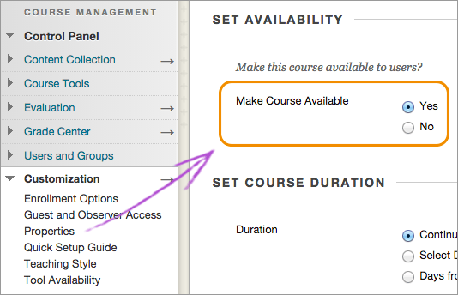
- Select Submit.
- You can also quickly change the availability of your course in the main home page. At the top management area next to Enter Student Preview, select the Make unavailable icon.
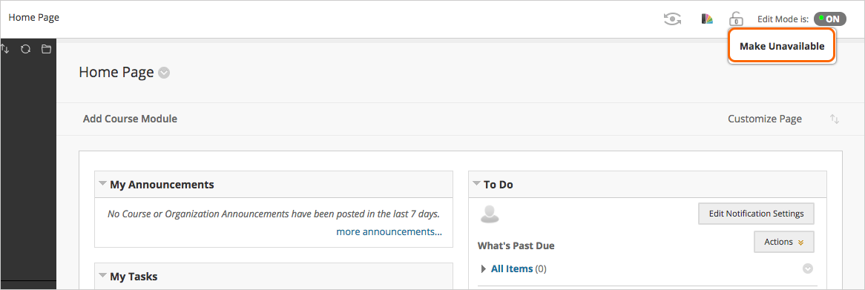

Coping Courses and/or Material
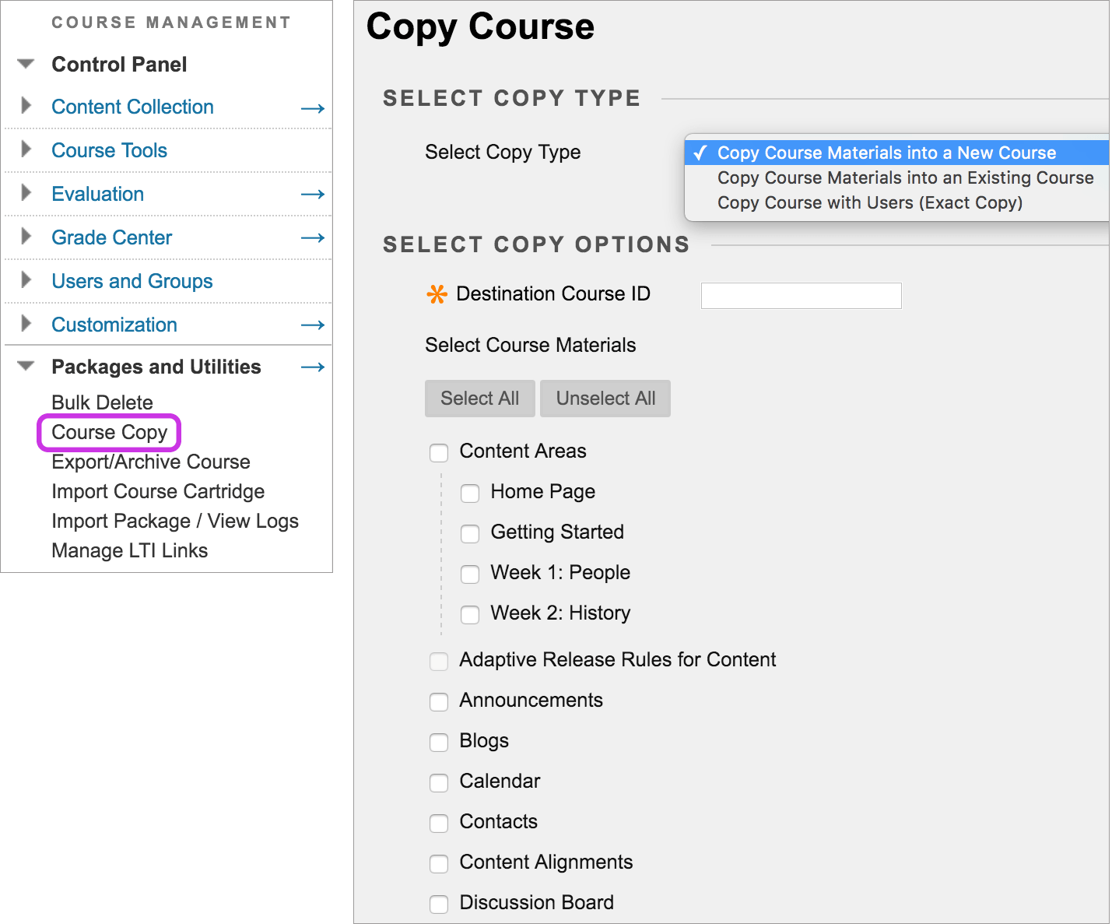
- Access the course you want to copy.
- On the Control Panel, expand the Packages and Utilities section and select Course Copy.
- Select the appropriate option:
  - Copy Course Materials into a New Course
  - Copy Course Materials into an Existing Course
  - Copy Course with Users (Exact Copy)
- In the Destination Course ID box, type a course ID for the new course that will be created and populated with content from the current course. Make sure that the new course ID matches the naming convention used at your institution. The course ID cannot include spaces or characters other than numbers and letters (A-Z), dash (-), underscore (_), and period (.). The course ID must be unique and remain static. After you create the copied course, you cannot edit the course ID.
- If you chose Copy Course Materials into a New Course or Copy Materials into an Existing Course, select the course materials that you want to copy over.
A course copy operation cannot be completed if you don't select at least one of these areas: Content, Contacts, or Settings. If you do not select one, a warning appears and Blackboard Learn cannot create a new course.
- In the File Attachments section, select the option to copy links to:
  - Copy Links to Course Files: No copies of linked files are included in the copy. The copied course will have the same set of links. Those links will point back to the original location of the link defined in the origin course.
  - Copy links and copies of the content: Make copies of linked files, but only those files that are linked. Files within the course's home folder that aren't linked to any content within the course aren't included in the copy.
  - Copy links and copies of the content (include entire course home folder): Make copies of all files in the course's home folder regardless of whether those files are linked to course content.
You need manage permission on an item to include copies of those files. If you do not have this permission, you may be missing some files after the copy.
- Select the Folder for Content Collection Files, if applicable.
- Select Enrollments to copy the list of users in the course. User records, such as discussion activity and grades will not be copied. User records are only copied if you select the Copy Course with Users (Exact Copy) option.
- Select Submit.

CONTENT
Creating Content in a Course
You create your individual pieces of content in content containers: content areas, learning modules, lesson plans, and folders. In a content container, you create content from menus for content items, tests, assignments, and links to tools.
As you create content, you can set its options, such as availability. You can create content and make it unavailable to students until you are ready for them to view it. You can also limit which content items students see based on date, time, individual users, course groups, and their performance on graded items.
You can restrict access to the next assignment until each student completes a test. You can also require that the assignment does not appear until students complete the test and earn a score of at least 70 percent.
How to Create a Folder
You can create Course Files folders and sub-folders to organize your files. Creating a logical filing system makes it easy to locate and link to files when creating content in your course. The folder structure in Course Files is separate from folders in a content area of your course and has no impact on the presentation of the content.
Folders can also make it much easier to manage permissions for your content. If you want to allow certain users the ability to read, write, or remove items, you can group them in one folder and edit permission for the folder rather than on individual items.

Create a Folder
You can create folders in the top-level folder of Course Files or inside another folder.
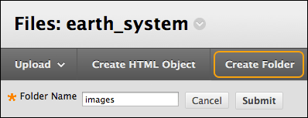
- Go to the area of Course Files where you want to create a new folder.
- Select Create Folder and type a name.
- Select the folder's title to create one or more sub-folders to further organize content.

Edit Folder Settings
You can edit the name of any folder except the top-level course ID folder. Changing a folder's name does not break any links to content in your course. Open a folder's menu and select Edit Settings.
Adding Files
You can add content in four ways:
- Upload files and folders into Course Files, either one at a time or in batches, using the drag-and-drop or the browse functions.
- Upload files from your computer when creating content with Browse My Computer.
- Create HTML objects in Course Files and upload files.
- Use WebDAV for direct upload, editing, and management of files in Course Files from your computer desktop or through WebDAV capable applications.

Drag-and-Drop Files
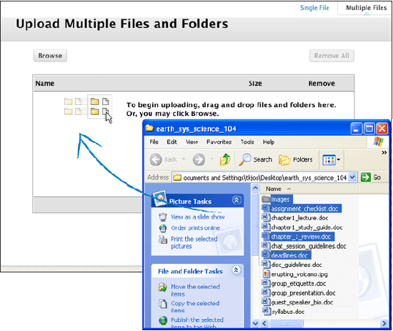
- Go to the Course Files folder where you want to upload the files.
- Point to Upload and select Upload Files.
- Select Multiple Files at the top of the page, if needed.
- On your computer, open the folder that contains the files and folders to upload. Position the folder next to the Upload Multiple Files and Folderspage.
- Select the files and drag them into the upload box on the Upload Multiple Files and Folders page. If you try to upload a file with the same name as an existing file, the system asks if you want to overwrite the current file.
- The files and folders appear in the upload box. To delete a file in the list, select the X in the Remove column. The contents of folders appear individually in the upload list, but after they are uploaded, they are contained in their parent folders.
- Select Submit. A status bar displays the progress of the upload.

Browse For Files
- Go to the Course Files folder where you want to upload the files.
- Point to Upload and select Upload Files.
- Select Multiple Files at the top of the page, if needed.
- On the Upload Multiple Files and Folders page, select Browse and open the folder on your computer containing the files and folders to upload. Select the files.
- The files and folders appear in the upload box. To delete a file in the list, select the X in the Remove column. The contents of folders appear individually in the upload list, but after they are uploaded, they are contained in their parent folders.
- Select Submit. A status bar displays the progress of the upload.

ASSIGNMENTS
With assignments, you can create coursework and manage the grades and feedback for each student separately. You can create assignments in content areas, learning modules, lesson plans, and folders.
When you create an assignment, a Grade Center column is created automatically. From the Grade Center or Needs Grading page, you can see who has submitted their work and start grading. Students access their grades from their My Grades pages or the assignment's Review Submission History page.
You can also create a group assignment and release it to one or more groups in your course. Each group submits one collaborative assignment and all members receive the same grade. You can create a single assignment and assign it to all groups, or create several unique assignments and assign them to individual groups.

Create an Assignment
You can create assignments in content areas, learning modules, lesson plans, and folders.
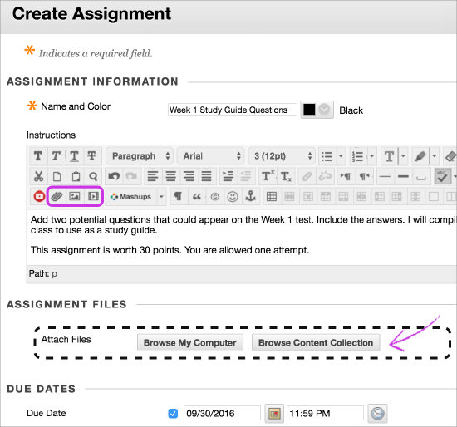
- From the Assessments menu, select Assignment and provide the name, instructions, and the files students need. You can use the functions in the editor to format text and add files. You can also add files in the Assignment Files section.
- Select Browse My Computer to upload a file from your computer. The file is saved in the top-level folder in your course's file repository: Course Files or the Content Collection. You can also attach a file from the repository.
-OR-
Drag files from your computer to the "hot spot" in the Attach Files area. If your browser allows, you can also drag a folder of files. The files will upload individually. If the browser does not allow you to submit your assignment after you upload a folder, select Do not attach in the folder's row to remove it. You can drag the files individually and submit again.
You will not be able to drag files to upload if your institution uses an older version of Blackboard Learn.
You can use the file name or provide another name for the file.
- Optionally, select a Due Date. Assignments with due dates automatically show in the course calendar.
- In the Grading section, type the Points Possible and optionally, add a rubric. Expand the sections to make selections such as anonymous grading, how the grade is displayed, and the number of attempts. You can allow more than one attempt on an assignment.
- Make the assignment available when you are ready for students to access it. Select the appropriate options for availability, tracking, and display dates. Display dates do not affect an assignment's availability, only when it appears.
- Select Submit.

How to Grade Assignments
You can start grading on the Needs Grading page or in the Grade Center. On the Grade Assignment page, you can view, comment on, and grade student-submitted assignment files.
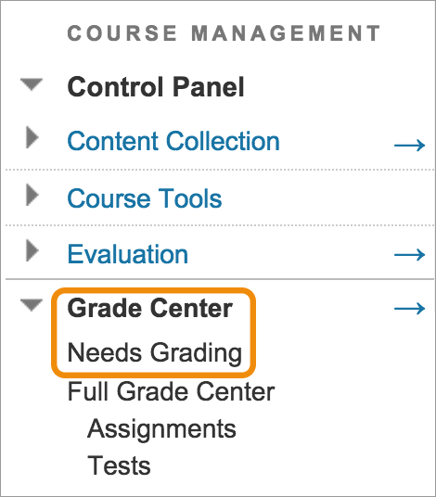

Using SafeAssign
SafeAssign compares submitted assignments against a set of academic papers to identify areas of overlap between the submitted assignment and existing works. It is effective as both a deterrent and an educational tool. Use SafeAssign to review assignment submissions for originality and create opportunities to help students identify how to properly attribute sources rather than paraphrase.
SafeAssign is based on a unique text matching algorithm capable of detecting exact and inexact matching between a paper and source material.
You can use SafeAssign plagiarism checking for any of your assignments.
- On the Create Assignment page, expand Submission Details.
- Select Check submissions for plagiarism using SafeAssign.
- Optionally, select one or both options:
  - Allow students to view the SafeAssign Originality Reports on their submissions.
  - Exclude all student submissions for this assignment from the institutional or global reference databases.
- Complete the Create Assignment page.
- Select Submit.
When you create a SafeAssignment, a grade column is automatically created in the Grade Center. When a SafeAssignment is ready for grading, the Needs Grading icon appears in the Grade Center cell. Grade SafeAssignments from the Grade Center or access them from the Needs Grading page.

TESTS
You can use tests and surveys to measure student knowledge, gauge progress, and gather information from students. Remind your students that they need to use a wired connection when they take tests. Wireless connections are more prone to network issues. The stability of the signal depends on how long and how much bandwidth students draw, similar to 4G phone data connections.

Create a Test/Survey and Add Questions
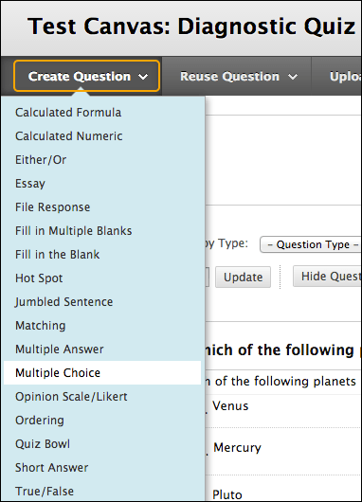
Control Panel > Course Tools > Tests, Surveys, and Pools > Tests or Surveys
- On the Tests page, select Build Test.
- On the Test Information page, type a name. Optionally, provide a description and instructions.
- Select Submit.
- On the Test Canvas, from the Create Question menu, select a question type.
- On the Create/Edit page, provide the necessary information to create a question.
- Select Submit.
- When you have added all the questions you need, select OK. The test is added to the list on the Testspage and is ready to make available to students.

Add Questions to An Existing Test/Survey
You can add new questions exactly where you want them on the Test or Survey Canvas. Select the plus sign before or after another question and choose a question type.
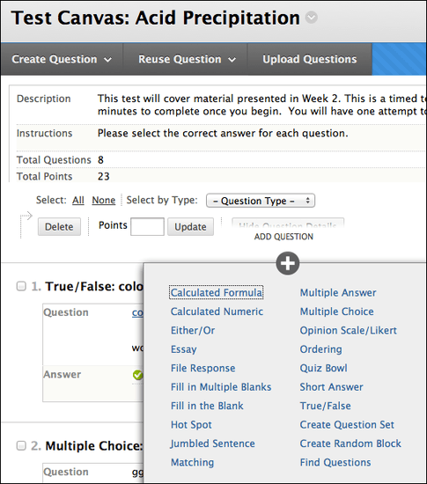
You can also change the value for individual questions as needed.

Reorder Questions
Questions are numbered automatically in the order you add them. The question numbers update when you reorder or randomize them. To prevent confusion, do not use numbers to reference other questions within the test.
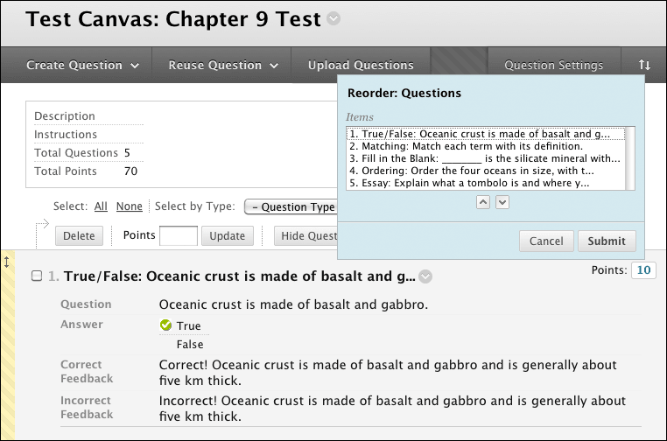
On the Test or Survey Canvas, you can use the drag-and-drop function to reorder questions. Press the arrows next to a question and drag it to a new location.
Or, select the Keyboard Accessible Reordering icon. Select a question and use the Move Up and Move Down icons following the Items box to adjust the order.
Only new test attempts are affected by the changed order if the test is not set to display questions in random order. Students who have already made submissions see the original order.

Add a Test/Survey to a Content Area
After you create a test or survey, the next step is to deploy it. First, you add the test or survey to a content area, folder, learning module, or lesson plan. Then, you make the test or survey available to students.
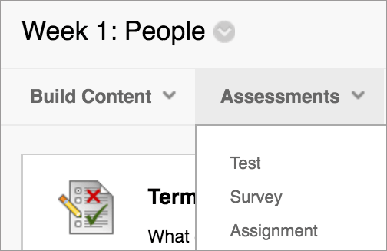
- Navigate to where you want to add a test or survey.
- Select Assessments to access the menu and select Test or Survey.
- Select a test or survey from the list.
- Select Submit. The Test or Survey Options page appears.
- Make the test or survey available to students.
- Optionally, select the options for feedback and display, and set the due date and display dates.
- Select Submit.

GRADING

Access the Grade Center
You access the Grade Center from the Control Panel. Expand the Grade Center section to display the links to the Needs Grading page, the Full Grade Center, and the smart views.
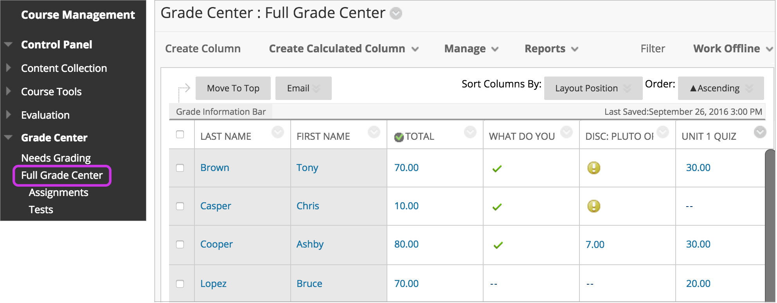
On the Needs Grading page, you can begin grading assignments, group assignments, tests, blog and journal entries, wiki page saves, and discussion posts.
The Full Grade Center link displays all columns and rows in the Grade Center and is the default view of the Grade Center.
The smart view links appear as an indented list in the Full Grade Center section. A smart view is a focused look at the Grade Center and shows only the data that matches a set of criteria. You can use smart views to quickly find data when the Grade Center includes a great number of students and columns. For example, the default Tests smart view displays only test columns.
You can customize your view of the Grade Center and create grading schemas, grading periods, categories, and columns to present and gather the information you need.

Grade Center Functions
You can perform many actions in the Grade Center with the functions appearing in two rows at the top of page.
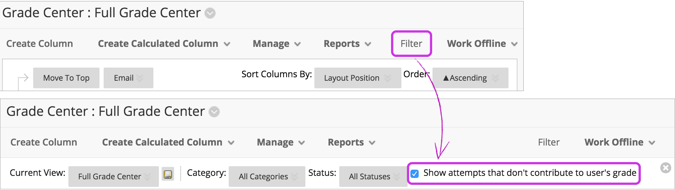
These functions appear in the first row:
- Create Column: Create a grade column.
- Create Calculated Column: Access a menu with options to create calculated columns.
- Manage: Options include grading periods, schemas, categories, color coding, row visibility, email, and column organization.
- Reports: Create reports from Grade Center data and access the grade history for all students.
- Filter: Narrow your view of the Grade Center data. Select Filter to expand the field and select an option from these menus:
  - Current View: Includes the Full Grade Center view, smart views, and grading periods. You can select one of the views to use as the default view with the Set Current View as Default icon.
  - Category: Includes all default categories and those you have created.
  - Status
  - Show attempts that do not contribute to user's grade: The default view in a grade cell's menu shows each attempt made. You can clear the check box and see only the attempt you need to grade in each grade cell's menu.
These functions appear in the second row:
- Move to Top: Select one or more check boxes for users and select Move to Top to move the rows to the first positions in the grid.
- Email: Select one or more check boxes for users, select Email, and make a selection.
- Sort Columns By: Access a menu with options to sort the Grade Center items.
- Order: Sort the data in ascending or descending order. The view remains until you sort columns Ragain or log out.
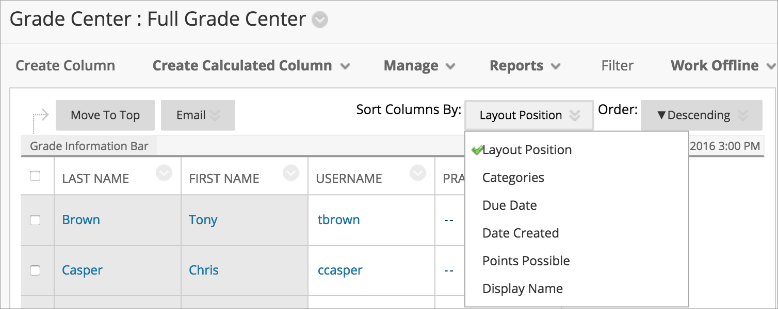

Access Grade Center Menus
Throughout Blackboard Learn, items may have menus with options that are specific for each item.
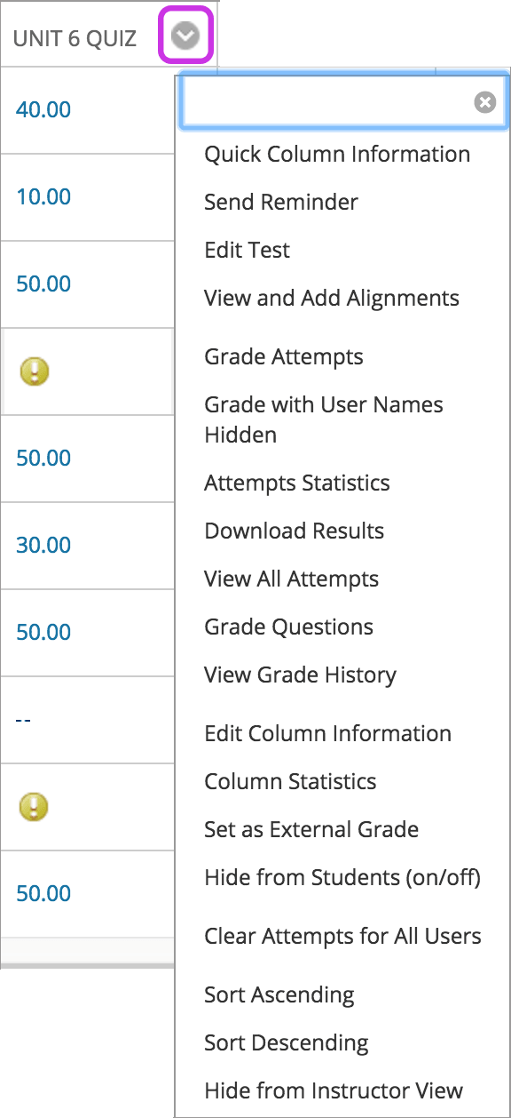
In the Grade Center, all cells and column headers have a menu. For example, a test column's menu includes options for Column Statistics and Grade Questions. For a non-grade column, such as First Name, you only have the options to hide the column and sort the cells. If an option does not appear in the menu, you can't perform the action on that column, row, or cell.
Point to a cell or column header to see the Click for more options icon. Select the icon to access the menu.

REPORTS
You can create printable reports for your courses and students. You can also create a progress report that contains grades from a particular grading period for a defined group of students in a class. You can only choose students within one section to appear in a report. You must run a separate report for each section. You can customize reports. You can include report header and footer information, a signature line, date, and course information. When you print, only one student per page is allowed.

Create a Report
In the Grade Center, access the Reports menu and select Create Report.
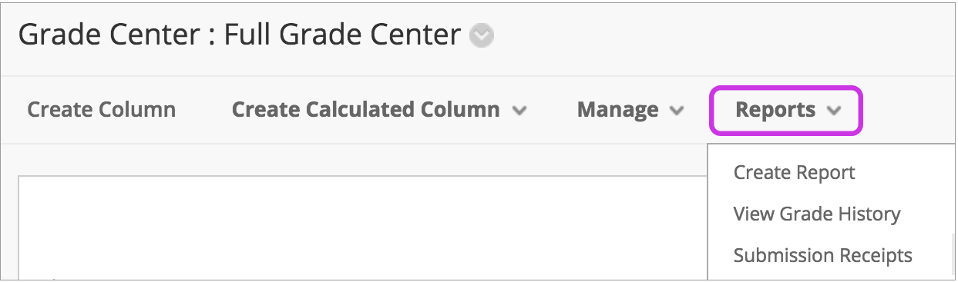
You can make selections and provide text for each section. In the footer, you may edit the display date for the report creation date.
When you select the users you want to include in the report, you cannot include groups until they are created.
To select multiple students, press the Shift key and select the first and last items. To select students out of sequence, press the Ctrl key and select each student needed. For Macs, press the Command key instead of the Ctrl key.
You may preview the report before you submit it.

Save or Print a Report
To save a report, use your browser's Save As function and choose the location. The report is saved as an HTML file.
To print a report, use your browser's print function. Select the appropriate options. See your browser's online help for more information about printing.

GRADE CENTER STATISTICS
In the Grade Center, you can view statistical information related to a column and any user. The statistics pages are read-only. You cannot edit grades or other information.

User Statistics Page
The User Statistics page displays a student's statistics. In the Grade Center, access a user's menu and select View User Statistics. On the User Statistics page, you can view student information and the percentage and total number of items completed as of the present time and date.
The student's contact information is generated from what a student has chosen to share.
To view another user's data while on the User Statistics page, select the appropriate student name from the User menu and select Go. Use the left and right arrows to move alphabetically to the previous or next student. You can send students emails from this page in the Contact section.
To change the statistics you can view on this page, select a view from the Show Statistics For menu and select Refresh. By default, the full view of the Grade Center is shown, but if you choose another view, then those statistics are shown.

Column Statistics Page
The Column Statistics page displays statistics for a grade item, including average, median, and standard deviation. You can also view how many need grading and how the grades are distributed.
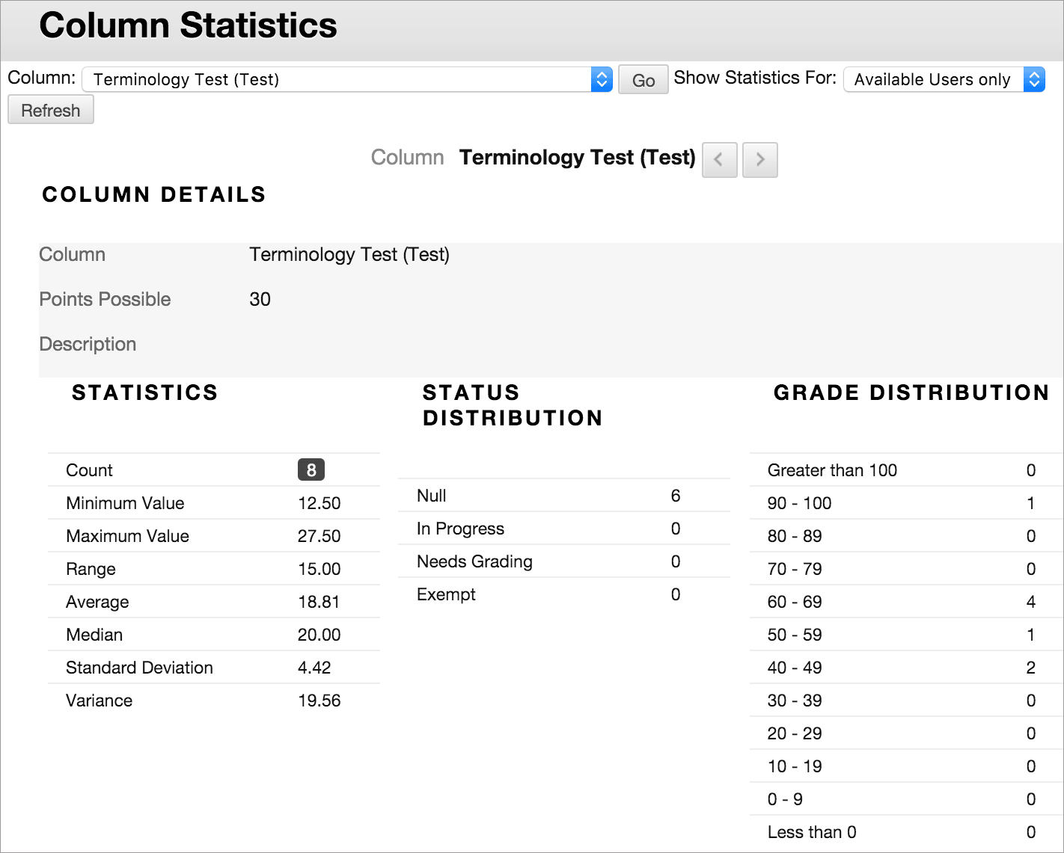
In the Grade Center, access a column header's menu and select Column Statistics.
You can include unavailable students in the statistics. Access the Show Statistics For menu and select All Users. Select Refresh.
To view another column, select it from the Column menu and select Go. Use the Next Column and Previous Column icons to move to another column.

Available Statistics
- Minimum and Maximum Values: The lowest and highest values of all graded columns in the Grade Center
- Range: The numeric range between the lowest and highest grades for an item
- Average: The statistical average of the item
- Median: The midpoint score of the items
- Standard Deviation: The difference between the values of the item and the average of the item
- Variance: A statistical measure of the spread or variation of the items

ANNOUNCEMENTS
Announcements are an ideal way to post time-sensitive information critical to course success. Add announcements for these types of course activities:
- Due dates for assignments and projects
- Changes to your syllabus
- Corrections/clarifications of materials
- Exam schedules
You can add, edit, and delete announcements from the Announcements page. When you add an announcement, you can also send it as an email to students in your course. Students will receive the announcement even if they do not log into your course.

Create an Announcement
Announcements appear in the order you post them. The most recent announcement appears first.
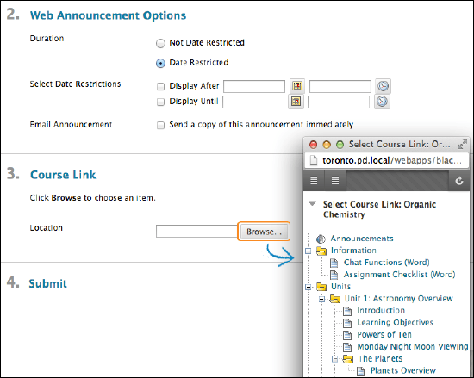
- On the Control Panel, go to Course Tools > Announcements.
- Select Create Announcement on the action bar.
- Type a Subject, which appears as the title of the announcement on the Announcements page.
- Type your message.
- In the Web Announcements Options section, choose to restrict the announcement by date or not.
  - If you choose Not Date Restricted, the announcement is visible until you remove it.
  - If you choose Date Restricted, select the Display After and Display Until check boxes to enable the date and time selections. Provide the date and time restriction settings.
- Select the Email Announcement check box to send students an email containing the announcement. The email is sent to all students, even those who choose not to receive announcement notifications through email. Your institution controls if this option is available.
- Optionally, in the Course Link section, select Browse to link to a course area, tool, or item.
Links to course content will not appear in the email announcement if you choose to send one.
- Select Submit.

Addendum 2
Aviation Accreditation Board International (AABI)
What is AABI?
AABI started out as the Council on Aviation Accreditation (CAA) as a non-profit organization in 1988. The organization began as aviation colleges and universities sought to establish standards for their programs, as well as allow for peer and industry review. After years of work, the organization was able to achieve status as an accreditation “body,” and has maintained its status since 2002. In July 2006, the organization decided to change its name to the Aviation Accreditation Board International during its annual meeting convention. The organization recognizes the name change as a way to “….advance quality aviation education worldwide through accreditation and leadership” (AABInternational, 2017).
Since receiving the status of an accreditation “body”, AABI’s current scope of accreditation is geared toward non-engineering aviation programs. These programs can be associate, baccalaureate, or graduate level offered by colleges and universities. It does not include private organizations or private flight schools. As of now, various colleges and universities have AABI accredited programs, including: Arizona State University, Embry-Riddle Aeronautical University, Florida Institute of Technology, Kent State University, Purdue University, The Ohio State University, University of North Dakota, and many more.
The goals of AABI, as stated on their website, are:
- To stimulate collegiate aviation program excellence and self-improvement
- Establish uniform minimum educational quality criteria
- Increase the credibility, integrity, and acceptance of collegiate aviation programs within institutions of higher education and all aspects of the aviation community, including industry, government, and the public-at-large.
(AABInternational, 2017)

What is Accreditation?
As stated by the third goal above, when a college or university becomes accredited, their validity and integrity with other higher education institutions and the community have been established. Additionally, AABI’s accreditation has three fundamental purposes:
  - Ensuring quality of the program
  - Assist in the improvement of the program
  - Maintain relevance of education with the industry it serves
(AABInternational, 2017)
It is important to note that when a college or university becomes accredited, it is the university as a whole. It is not like a certification or licensure that only applies to individuals.

What are the Requirements to be accredited?
For a college or university to become accredited, it must comply with various rigorous tasks and criteria. These tasks and criteria consist of all aspects of the program, to include management of resources, interactions of faculty and students, achievement of learning goals and objectives, etc. There are various documents that are submitted yearly to the AABI organization that detail the information required to not only be accredited, but to maintain its accreditation status. For more details on the specific tasks and criteria, reference document AABI-201-Accreditation Criteria, which is attached for review.

* The information gathered for this addendum was retrieved from AABI’s website. The reference is below.
AABInternational. (2017). About AABI. http://www.aabi.aero/about-aabi/

